Name:Nandhini.R

Roll NO:727721euai036

CC1:

Question-1:

Code:

package com.example.main.testing.cc1;

import org.openqa.selenium.By;

import org.openqa.selenium.Keys;

import org.openqa.selenium.WebDriver;

import org.openqa.selenium.edge.EdgeDriver;

import org.testng.Assert;

import org.testng.annotations.BeforeTest;

import org.testng.annotations.Test;

import io.github.bonigarcia.wdm.WebDriverManager;

public class cc1_01 {

WebDriver driver =new EdgeDriver();

*@BeforeTest*

public void beforetest() throws InterruptedException{

WebDriverManager.*edgedriver*().setup();

driver.manage().window().maximize();

}

*@Test*(priority=1)

public void login() throws InterruptedException{

driver.get("https://www.saucedemo.com/");

driver.findElement(By.*xpath*("//*[@id=\"user-name\"]")).sendKeys("standard_user");

driver.findElement(By.*xpath*("//*[@id=\"password\"]")).sendKeys("secret_sauce",*Keys*.***ENTER***);

String url = driver.getCurrentUrl();

Assert.*assertEquals*(url,"https://www.saucedemo.com/inventory.html");

// driver.findElement(By.xpath("//*[@id=\"add-to-cart-sauce-labs-bike-light\"]")).click();

// driver.findElement(By.xpath("//*[@id=\"shopping_cart_container\"]/a")).click();

}

*@Test*(priority=2)

public void addtocart() throws InterruptedException{

driver.findElement(By.*xpath*("/html/body/div/div/div/div[2]/div/div/div/div[2]/div[2]/div[2]/button")).click();

}

*@Test*(priority=3)

public void clickcart() throws InterruptedException{

// driver.findElement(By.xpath("/html/body/div/div/div/div[2]/div/div/div/div[1]/div[2]/div[2]/button")).click();

Thread.*sleep*(7000);

driver.findElement(By.*xpath*("/html/body/div/div/div/div[1]/div[1]/div[3]/a")).click();

String url2 = driver.getCurrentUrl();

Assert.*assertEquals*(url2,"https://www.saucedemo.com/cart.html");

driver.findElement(By.*xpath*("/html/body/div/div/div/div[2]/div/div[2]/button[2]")).click();

String url3 = driver.getCurrentUrl();

Assert.*assertEquals*(url3,"https://www.saucedemo.com/checkout-step-one.html");

driver.findElement(By.*xpath*("/html/body/div/div/div/div[2]/div/form/div[1]/div[1]/input")).sendKeys("priya");

driver.findElement(By.*xpath*("/html/body/div/div/div/div[2]/div/form/div[1]/div[2]/input")).sendKeys("ram");

Thread.*sleep*(7000);

driver.findElement(By.*xpath*("/html/body/div/div/div/div[2]/div/form/div[1]/div[3]/input")).sendKeys("625531");

driver.findElement(By.*xpath*("//*[@id=\"continue\"]")).click();

String url4 = driver.getCurrentUrl();

Assert.*assertEquals*(url4,"https://www.saucedemo.com/checkout-step-two.html");

System.***out***.println(driver.findElement(By.*xpath*("/html/body/div/div/div/div[2]/div/div[1]/div[3]/div[2]/div[2]/div")));

String title=driver.getTitle();

Assert.*assertEquals*(title,"Swag Labs");

}

}

Screenshots:





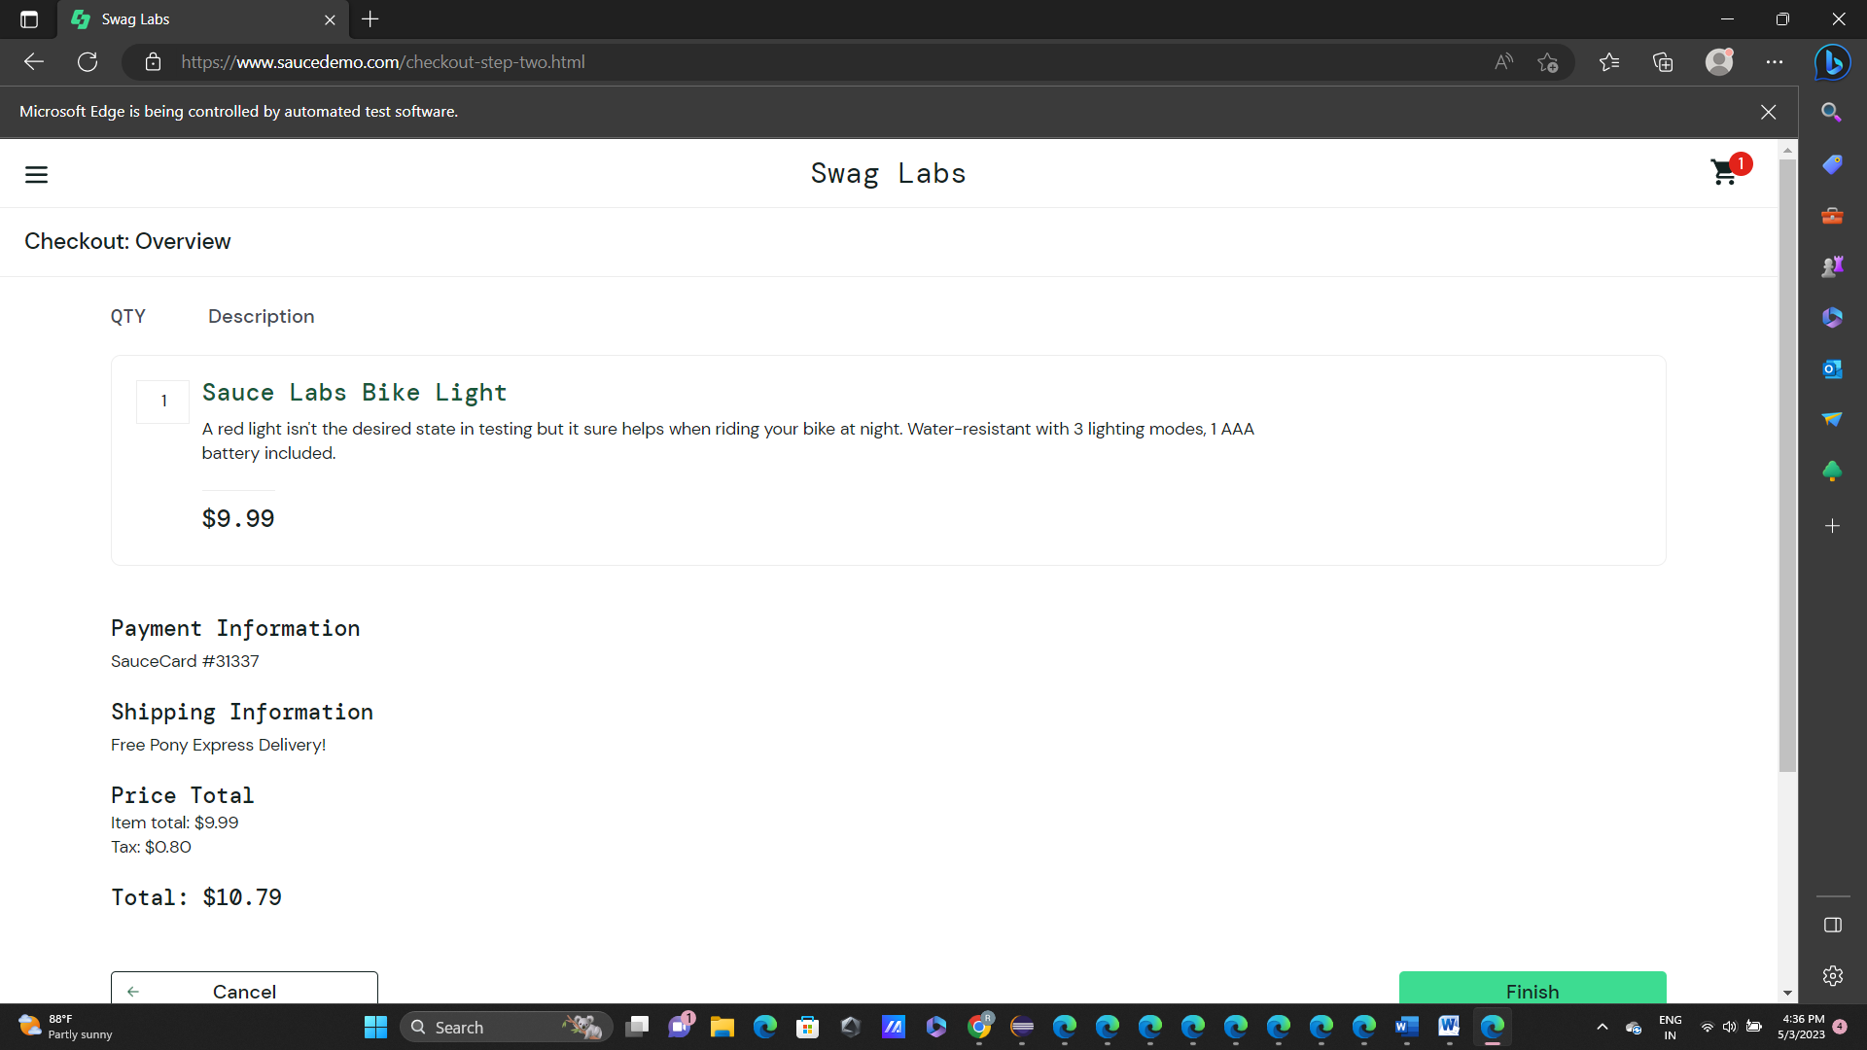

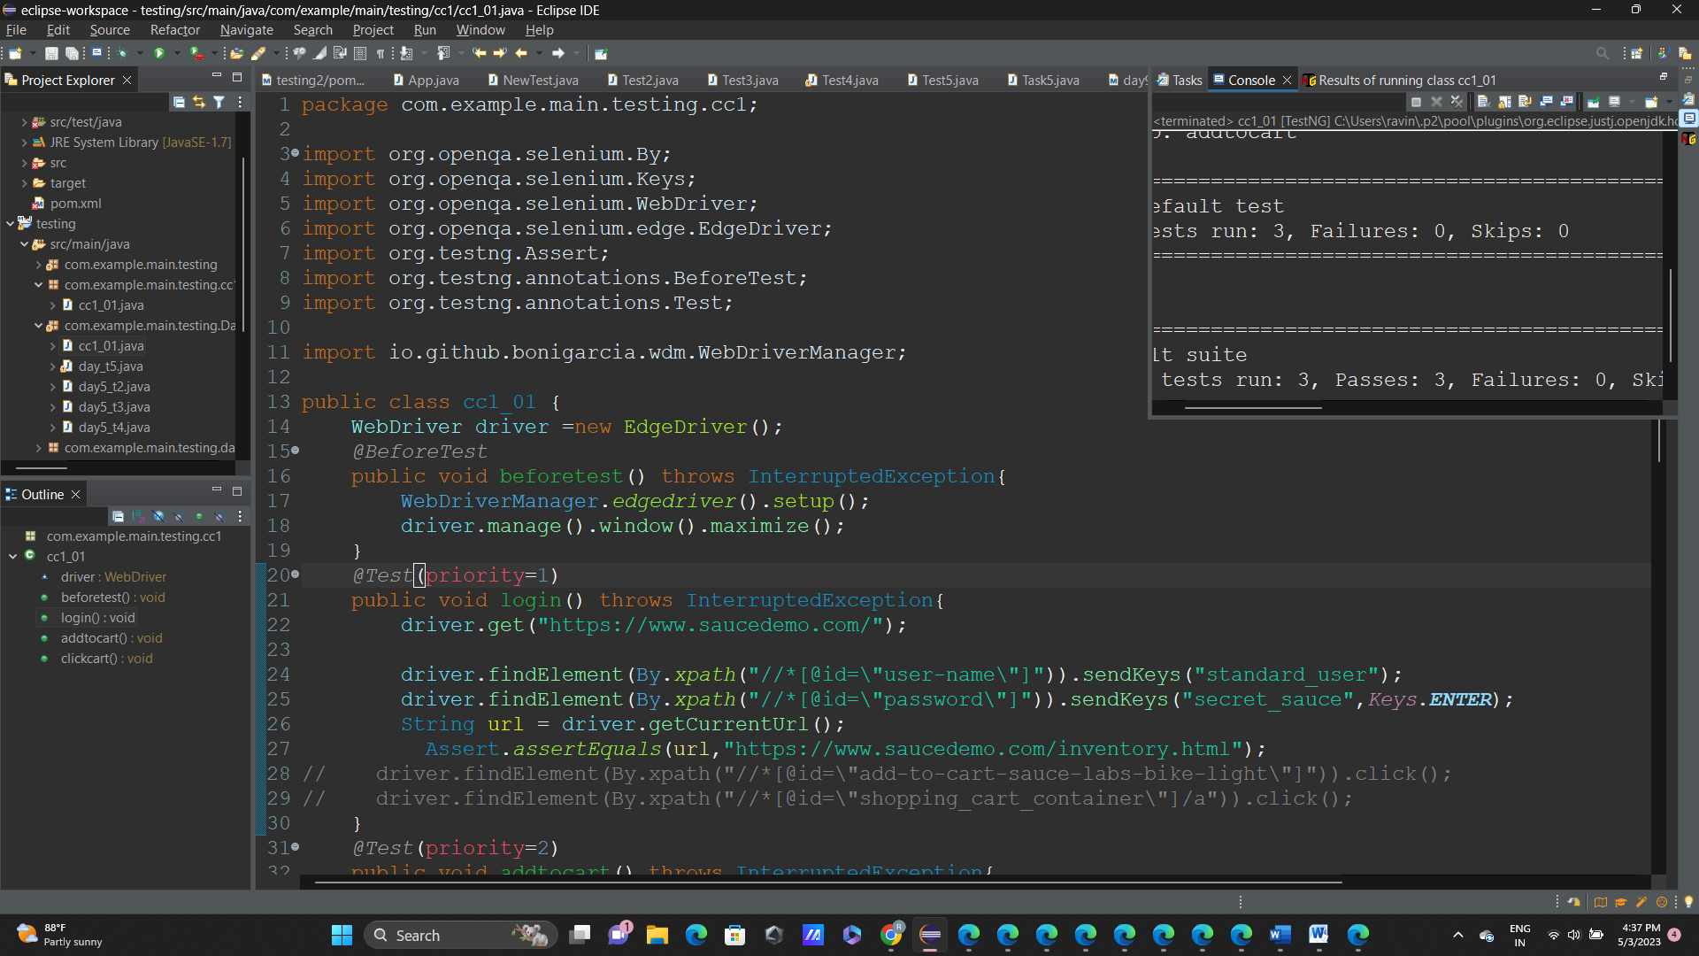

Question-2:

Coding:

import org.openqa.selenium.By;

import org.openqa.selenium.WebDriver;

import org.openqa.selenium.WebElement;

import org.openqa.selenium.firefox.FirefoxDriver;

import org.testng.annotations.AfterTest;

import org.testng.annotations.BeforeTest;

import org.testng.annotations.Test;

public class cc_q2 {

WebDriver driver;

@BeforeTest

public void beforeTest() {

driver=new FirefoxDriver();

}

@Test

public void Test1() throws InterruptedException {

String url="https://www.saucedemo.com/";

driver.get(url);

driver.manage().window().maximize();

Thread.sleep(5000);

System.out.println("opened");

driver.findElement(By.xpath("//*[@id=\"user-name\"]")).sendKeys("standard_user");

Thread.sleep(2000);

driver.findElement(By.xpath("//*[@id=\"password\"]")).sendKeys("secret_sauce");

driver.findElement(By.xpath("//*[@id=\"login-button\"]")).click();

Thread.sleep(5000);

driver.findElement(By.xpath("//*[@id=\"header_container\"]/div[2]/div/span/select")).click();

Thread.sleep(2000);

driver.findElement(By.xpath("//*[@id=\"header_container\"]/div[2]/div/span/select/option[1]")).click();

WebElement az1=driver.findElement(By.xpath("//*[@id=\"item_4_title_link\"]/div"));

String taz1=az1.getText();

System.out.println(taz1);

driver.findElement(By.xpath("//*[@id=\"header_container\"]/div[2]/div/span/select")).click();

Thread.sleep(2000);

driver.findElement(By.xpath("//*[@id=\"header_container\"]/div[2]/div/span/select/option[2]")).click();

WebElement az2=driver.findElement(By.xpath("//*[@id=\"item_3_title_link\"]/div"));

String taz2=az2.getText();

System.out.println(taz2);

driver.findElement(By.xpath("//*[@id=\"header_container\"]/div[2]/div/span/select")).click();

Thread.sleep(2000);

driver.findElement(By.xpath("//*[@id=\"header_container\"]/div[2]/div/span/select/option[3]")).click();

WebElement az3=driver.findElement(By.xpath("//*[@id=\"inventory_container\"]/div/div[1]/div[2]/div[2]/div"));

String taz3=az3.getText();

System.out.println(taz3);

driver.findElement(By.xpath("//*[@id=\"header_container\"]/div[2]/div/span/select")).click();

Thread.sleep(2000);

driver.findElement(By.xpath("//*[@id=\"header_container\"]/div[2]/div/span/select/option[4]")).click();

WebElement az4=driver.findElement(By.xpath("//*[@id=\"inventory_container\"]/div/div[1]/div[2]/div[2]/div"));

String taz4=az4.getText();

System.out.println(taz4);

}

@AfterTest

public void afterTest() throws InterruptedException {

Thread.sleep(2000);

driver.quit();

}

}

Screenshot:

